Class Time:
Names:

Confidence Intervals: Confidence Interval Lab I

Student Learning Outcomes:
- The student will calculate the 90% confidence interval for the average cost of a home in the area in which this school is located.
- The student will interpret confidence intervals.
- The student will examine the effects that changing conditions have on the confidence interval.

Collect the Data
Check the Real Estate section in your local newspaper. (Note: many papers only list them one day per week. Also, we will assume that homes come up for sale randomly.) Record the sales prices for 35 randomly selected homes recently listed in the county. Complete the table.
1. Complete the table:

Describe the Data
  - Compute the following:
= _______
s_{x} = _______
n = _______
  - Define the Random Variable , in words.

  - State the estimated distribution to use. Use both words and symbols.

Find the Confidence Interval

- Calculate the confidence interval and the error bound.
  - Confidence interval:

  - Error Bound:

- How much area is in both tails (combined)?

- How much area is in each tail? 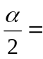

- Fill in the blanks on the graph with the area in each section. Then, fill in the number line with the upper and lower limits of the confidence interval and the sample mean.
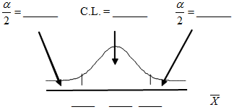

  - Some students think that a 90% confidence interval contains 90% of the data. Use the list of data on the first page and count how many of the data values lie within the confidence interval. What percent is this? Is this percent close to 90%? Explain why this percent should or should not be close to 90%.

Describe the Confidence Interval

- In two to three complete sentences, explain what a Confidence Interval means (in general), as if you were talking to someone who has not taken statistics.

- In one to two complete sentences, explain what this Confidence Interval means for this particular study.

Use the Data to Construct Confidence Intervals
- Using the above information, construct a confidence interval for each confidence level given.
Confidence level | EBM / Error Bound | Confidence Interval
50%
80%
95%
99%

- What happens to the EBM as the confidence level increases? Does the width of the confidence interval increase or decrease? Explain why this happens.

